# (SS 2014)

## Course Monitoring

### Task 1: Inclination Measurements and Plumbing (20%)

The Stuttgart Telecommunication Tower is a distinct construction, which is visible from far distances. Your engineering company obtains the assignment to monitor the tower and to determine possible deformations. The monitoring object has an overall height of 192 m.

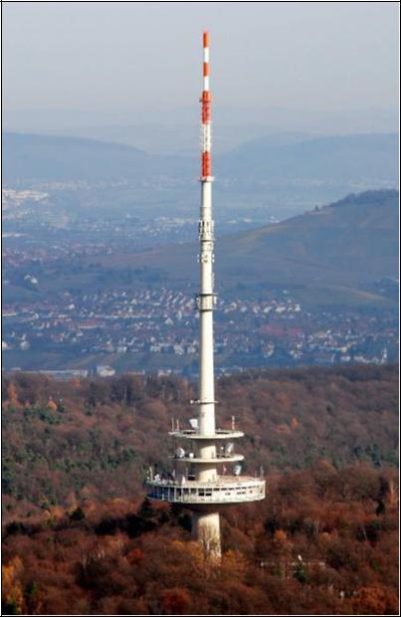

Figure 1:Telecommunication Tower Stuttgart

You decide to monitor the tower by using inclination measurement method. Additionally, plumbing method should be applied, to control the inclination measurements.

1. Please give a short overview of the two measuring techniques, under the aspects of accuracies and the measurement quantities.

|  |
| --- |
| Inclination measurement: measurement of the angle deviation from horizontal plane or indirectly from a vector plane. Angle of deviation is measured. Accuracy up to 0.1mgon.  Plumbing: measurement of the angle of deviation with respect to gravity vector. It can be realized with a mass attached with a tensed wired connecting the top and the bottom of the structure. Accuracy up to 0.5 - 1.0 mm. |

1. You decide to install 7 inclinometers along the tower. The distance between these measurement points is Si=32 m. Please perform a rough accuracy estimation for the measurement sites ***3*** and ***6,*** using the Law of Error

Propagation and calculate the standard deviation . The formula for the deformation is given as:  . Please use the information from Table 1.

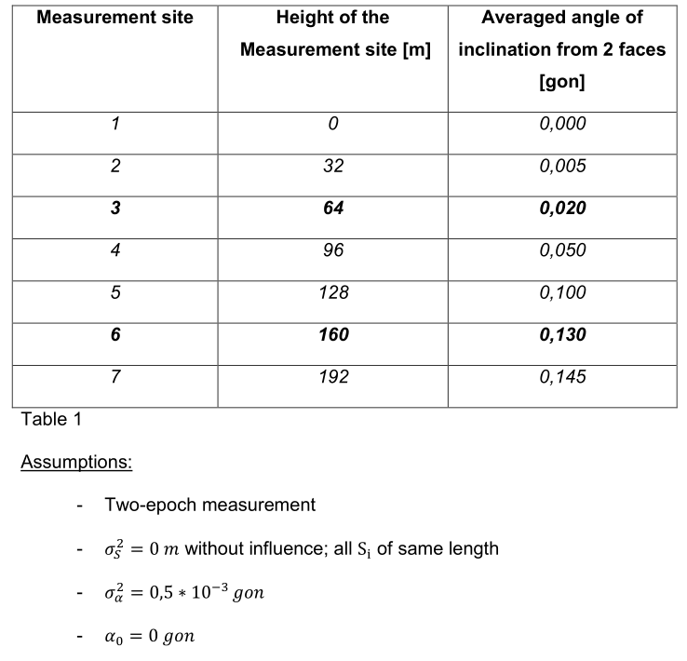

|  |
| --- |
|  |

### Task 2: Measurement Concept (15%)

Please design a measurement concept for the bridge that is displayed in Figure 2.

Use the table below to extract the movement information.

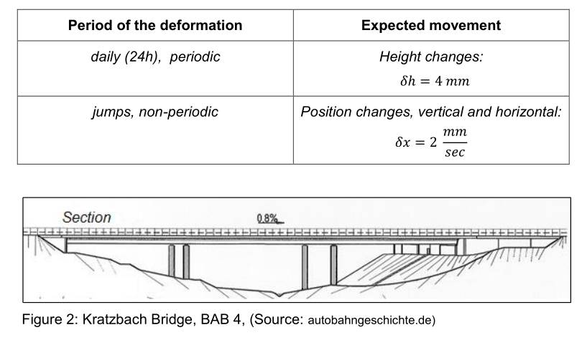

1. Please name possible causes for the expected deformations.

|  |
| --- |
| -Traffic  -Temperature  -Wind  -Hydrological causes |

1. What kind of reference system would you to choose? Please make a statement about the spatial discretization regarding the number of measurement sites and the position of points. Use Figure 2 to sketch some of your chosen point positions.

|  |
| --- |
| -Local reference system 2D.  -Two control points in the abutements.  -Several object points along the bridge with special attention in the center between the pillars. |

1. Please choose the measurement interval.

|  |
| --- |
| From daily deformation: 2×4mm = 8 mm |

1. Please define the measurement accuracies.

|  |
| --- |
| From periodic deformation: 4mm/50=0.08mm < Δx < 4mm/10=0.4mm  From non-periodic deformation: 2mm/5 = 0.4mm  Fixed accuracy: 4mm/5=0.8mm |

1. What is the sampling rate?

|  |
| --- |
| From periodic deformation: 24h/10=2.4h  From non-periodic deformation: 5(0.8mm)/2mm/s=2s |

1. Please choose the suitable measurement equipment with respect to deformations and their periods.

|  |
| --- |
| Measured quantity: Distance  Accuracy <= 0.8 mm 🡪 Precise levelling (Vertical) : acc. 0.5mm/km  🡪 Alignment (Hotizontal): acc. 0.5 – 1mm  Sampling rate <= 2s 🡪 Almost no limitation in sensor |

### Task 3: Deformation Analysis (15%)

1. Please name the 4 deformation models.

|  |
| --- |
| -Congruence  -Static  -Kinematic  -Dynamic |

1. Please describe the characteristics of the congruence model and name the main application.

|  |
| --- |
| - Only geometric changes in one point measuring two different epochs. (No time dependent, no consideration of time-acting forces). |

1. Suppose that you have a point network consisting of 3 height points. You decide to conduct a two-epoch deformation analysis. Within the network the coordinates should be tested for movements. Please test if the z-coordinate of point number 3 underlies movements or not. Use the following information:

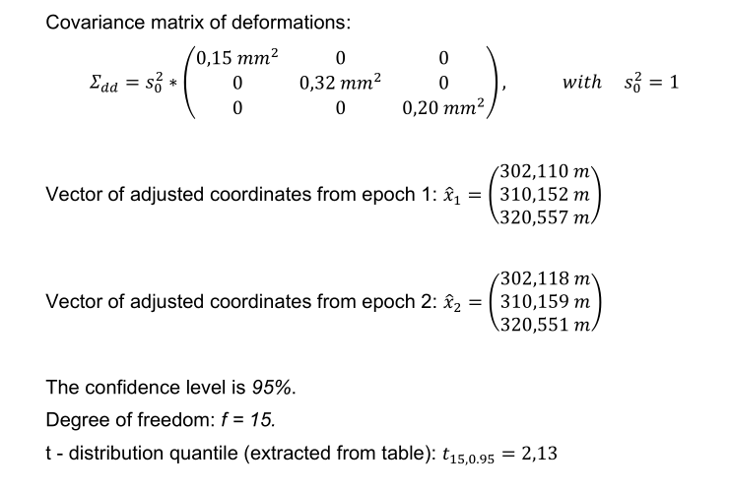

|  |
| --- |
|  |

## (SS2014) Course: Kinematic Measurement Systems

### Task 1: Robot Tachymeters (20%)

1. Please name 4 sensors that are integrated within a modern robot tachymeter.

|  |
| --- |
| Sensors:  -EDM  -Hz angles  -V angles  -Levelling sensors  -Pressure and temperature |

1. Please describe the general principle of an automatic rough pointing procedure applied in robot tachymeters and describe two of the four possible realizations.

|  |
| --- |
| Rough pointing is the process of recognition of target points realized without pre-information. Finished after reflector is aimed in the telescope’s range of vision.  Realizations:   1. **Special sensors for rough pointing (Leica Powersearch)**   -Reflection is detected at tachymeter (passive reflector)  -Laser plane (α<= 110°)  -Horizontal rotation -> detect Hz angle (50 mgon accuracy)  -Vertical angle > use of laser beam (50-70 mgon accuracy)   1. **Use of Active reflectors (Trimble)**   -Laser plane (α=10°)  -Reflector transmits the signal back to the instrument via modulated laser or infrared signal.  -Reflector is uniquely identified. |

1. The positioning in kinematic mode is a common method to determine the position of moving objects. Different kinds of errors play an important role in such kinematic modes. Please describe the difference between time delay and synchronization error.

|  |
| --- |
| - Dead time is the time needed to communicate the data transmission.  - Synchronization error appears due the time difference between different durations of measurement sensors. (Reduced by starting the measurements at different times for each sensor) |

### Task 2: GNSS (12%)

1. Besides tachymeters, GNSS gains more and more an important role in use as a kinematic sensor. Please name 3 GNSS modes for real-time applications and specify their accuracies.

|  |
| --- |
| GNSS (Static -Mode) 3-10m  DPGPS RTK 1-3cm  DGGPS Post Processing 1mm-2cm |

1. Please name the 6 main error sources for GNSS measurements.

|  |
| --- |
| Satellite’s orbit and clock  Ionosphere  Troposphere  Antenna Phase Centre |

### Task 3: Control of Moving Objects (18%)

1. In the lecture you have learned different steering models for wheeled vehicles. Please name 3 steering models.

|  |
| --- |
| Two-wheel (front/rear) steering  Four-wheel steering  Articulated/combined steering |

1. Please name the elements of a wheeled, front steered one-track-model (bicycle-model). Make a sketch and define the following quantities in the sketch:

|  |  |
| --- | --- |
|  | * Front steering angle (dA) * Slide slip angel at the centre of gravity (β0) * Distance between two axles (l) * Distance from rear axle to CG (lh) * Distance from front axle to CG (lv) * Center of gravity (SP) * Velocity of CG (V) * Velocity of rear wheel (Vh) * Velocity of front wheel (Vv) * Centre of circle (O) |

1. Please make a sketch of the detailed closed-loop-system and identify the following variables: u(t), w(t), e(t), y(t), z(t). What is the main task of the controlled system?

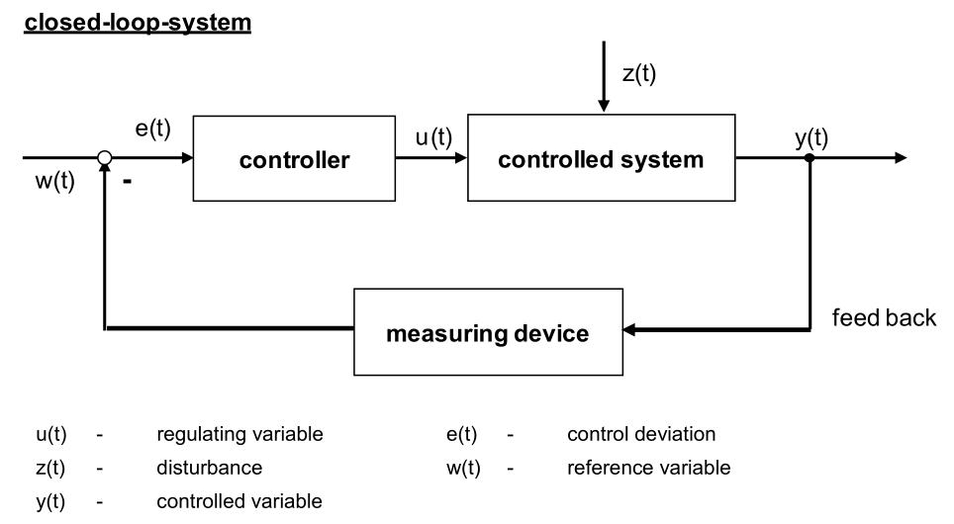

1. Please sketch the step response of a PT2-System. What does PT2-System mean?

|  |
| --- |
| P controller with a 2nd order time delay. |